**RESUME**

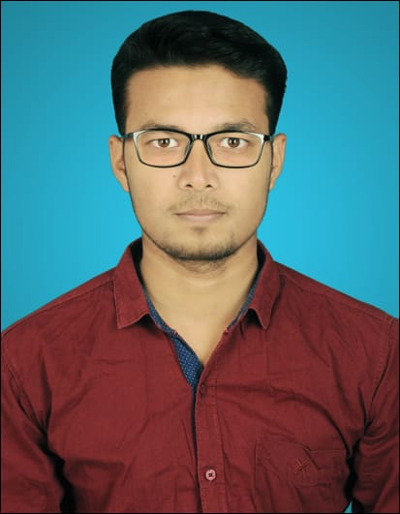**Rajendra Ranjan Choudhary**

S-Type, Adityapur,

P.O. - Adityapur, Jamshedpur,

Saraikela – Kharsawan,

Pincode - 831013,

Jharkhand, India

Phone: +91-7979999750

E-mail: [raj.choudhary01@outlook.com](mailto:shahrukh293@gmail.com)

# CAREER OBJECTIVE

Seeking a position where I can efficiently contribute my knowledge, skills and abilities for the growth of the organization and build my professional career with dedication and hard work.

# PROFESSIONAL EXPERIENCE

* **August, 2018 to October, 2019:** As aFrontend Web Developer in **REXCORP**, Ranchi
* **January, 2020 to Current:** As an IT Recruiter for **Apptad technologies**, Ranchi

# SKILLS

* Working on CSS
* Using Bootstrap design for front end web development
* **In AngularJs** working on:
  + Single Page Applications (SPA)
  + Two way data binding
  + AngularJs Building blocks: Directives, Factories & Controllers
  + Material design

# BASIC ACADEMIC CREDENTIALS

|  |  |  |  |
| --- | --- | --- | --- |
| **Qualification** | **Board/University** | **Year** | **Percentage** |
| B.Tech (Electronics and Communication  Engineering) | Kolhan University | 2013-2017 | 63% |
| Intermediate | M.P Board of Secondary Education | 2013 | 74% |
| High School | Jharkhand Academic Council | 2010 | 73.4% |

**TRAINING AND PROJECT**

**Vocational Training in B.Tech**

* + - Company Name : Bharat Sanchar Nigam Limited (BSNL).
    - Project Title : Data Communication
    - Duration **:** One Month

**Project in B.Tech**

* Study on Design of Advance Switch Mode Dc-Dc Regulator

# IT PROFICIENCY

* **Programming Language:** C
* **Web Programming:** HTML5, CSS, JavaScript, Bootstrap 4

**ACHIEVEMENTS**

* Won First Prize in quiz contest in year 2007.

 Actively participated in various sports activities for inter school.

 Attended **National Conference on Recent Advancement in Communication System & Data Engineering**

**INTERPERSONAL SKILL**

* Ability to rapidly build relationship and set up trust.
* Confident and Determined
* Ability to cope up with different situations.

# PERSONAL DETAILS

* **Father’s Name :** Anil Kumar Choudhary
* **Mother’s Name :** Sudhira Devi
* **Date of Birth :** 20thJanurary 1994
* **Gender :** Male
* **Language Known :** English & Hindi
* **Marital Status :** Single
* **Nationality :** Indian

# DECLARATION

I do hereby declare that the particulars of information and facts stated herein above are true, correct and complete to the best of my knowledge.

**Place: Rajendra Ranjan Choudhary**

**Date: (Signature)**